The Border Storm
A Monthly Information Source for the History and Preservation of the Quindaro Ruins.
Volume 1, Issue 6
November 12, 2003
The Quindaro Ruins Archaeological Park Project

Henry Drake: Courage at the voting Booth in Kansas Territory

Directors
Rev. E. Lewis Branch
Mr. Lavert Murray
Dr. Steve Collins
**************************
Steve Collins –Editor
scollins@toto.net

An 1850s pro-slavery newspaper points a disparaging finger at Quindaro, noting among other insults that Quindaro’s leadership had the audacity to allow a African American to vote in an election held when Quindaro was flourishing in 1859.
Henry Drake, a free African male living in Quindaro with his family came to vote in a city election. He approached the election judges, Mr. Afred Gray, who was the only mayor Quindaro was to have, and Mr. Elisha Sortor, whose later descendents would play a role in the more contemporary history of Kansas City, Kansas.
No picture survives of Henry Drake, but when he approached the voting area, both of the election judges allowed him to vote. This was a courageous act for the time. Westport newspapers had already charged Quindaro with seducing slaves to escape from their masters, and the plantation owners who lived across the river in Missouri had over-heard the talk of their slaves that Quindaro was a safe haven for the freedom seeker who was lucky enough to make it to this town.
When pro-slave authorities heard that Gray and Sortor had been bold enough to allow Henry Drake to vote they took action against both of the election judges. They pursued the two at the election post and threatened then with death and violence to the town. Even thought the judges excercized practicality and recanted their decision, Drake demonstrated courage in attempting to do the right thing.

Dennis Lawrence: Bringing Quindaro to Generations of Students

K.C.K.C.C. Theatre presents a
benefit performance of

Fly’in West

A play about the life of African American Women of Nicodemus, Kansas in 1898

November 20, at
K.C.K.C.C. All proceeds benefit the Save America’s Treasures grant.. Email quindaro@toto.net for further information and tickets.
Related Websites

Quindaro Chindowan Index

Quindaro page of Kansas City Kansas Public Library

Wyandotte Nation of Kansas

African Methodist Church

United Government of Wyandotte County and Kansas City Kansas

Dennis Lawrence will retire from Washington High school this school year. Throughout his career Mr. Lawrence has introduced literally hundreds of high school students to the Quindaro ruins. He is responsible for creating a website about Quindaro that is both informative and encourages students to participate actively in learning about the past. Dennis and his students recently volunteered to help clean up the ruins at the A.C. Strock “Peoples Variety Store” located on Kanzas Avenue in Old Quindaro. The students had a great time and learned a little more about one of the features the Western University Association is attempting to preserve through the Save America’s Treasures Grant.

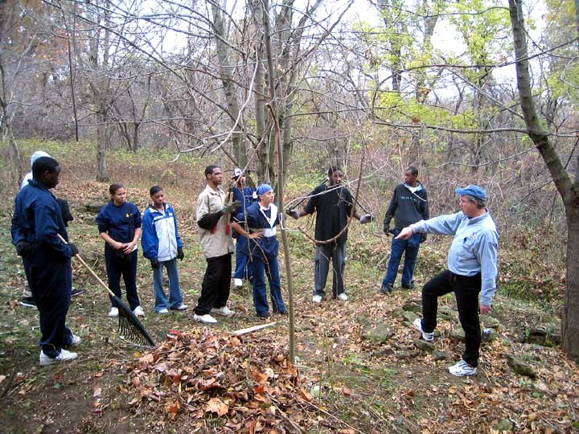

After nearly a
decade two cars
which were abandoned and burned at the Quindaro Ruins
have been removed. In late September the Kansas City Kansas Police Department brought heavy equipment to the site and literally plucked the cars out of their resting places in the service road. Shown at right is Officer Kent Anderson of Community Policing, supervising the job.

